Calculator: Features, Construction, Components, Operation, and Purpose

A calculator is typically a portable electronic device used to perform calculations, ranging from basic arithmetic to complex mathematics

1. External Features of a Calculator
The external features are the visible and accessible parts of a calculator that users interact with. They determine ease of use, visibility, and functionality.
- Display Screen
  - Shows numbers, symbols, and results.
  - Can display multiple lines in scientific or graphing calculators.
  - Types:
    - LCD (Liquid Crystal Display): Low power consumption, common in most calculators.
    - LED (Light Emitting Diode): Brighter, more visible in low light but consumes more energy.
    - Dot-Matrix or Graphic Display: For advanced graphing and plotting functions.
- Keypad / Buttons
  - Numeric keys (0–9): Input numbers.
  - Arithmetic keys (+, −, ×, ÷): Perform basic operations.
  - Function keys: Square root (√), percentage (%), reciprocal (1/x), factorial (!), etc.
  - Memory keys (M+, M−, MR, MC): Store and recall values for multi-step calculations.
  - Special keys:
    - C / CE: Clear all or clear entry.
    - = (Equals): Display the result.
    - ON/OFF: Power control.
- Power Supply
  - Battery: AA, AAA, or button cell.
  - Solar panel: Works in daylight to reduce battery use.
  - Auto-off function: Saves energy when idle.
- Outer Casing / Body
  - Provides protection to internal circuits.
  - Usually made of plastic, sometimes metal for durability.
  - Ergonomically designed for portability and comfortable handling.
- Indicator Lights / Status Display (optional)
  - Shows mode (scientific, statistical), memory usage, low battery, or error messages.
- Ports (optional)
  - USB or data ports in graphing or programmable calculators for data transfer to computers.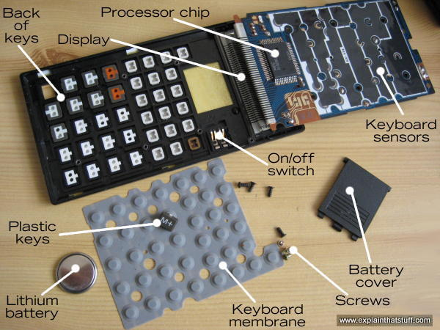

2. Physical Construction of a Calculator
Physical construction defines how the calculator is built to integrate internal and external components efficiently.
- Outer Casing
Protects internal electronic circuits from dust, moisture, and shocks.
Ergonomically designed for easy use and durability.
- Keypad / Buttons
Made of durable plastic or rubber.
Silicone membranes beneath buttons provide tactile feedback and make circuits contact accurately.
- Display Screen
Protected by transparent plastic or glass.
Advanced screens may allow color display or multiple lines for graphs and functions.
- Circuit Board (PCB)
Central part connecting all electronic components.
Holds the microprocessor, memory chips, and electronic components.
- Power Supply
Battery or solar panel connected to voltage regulation circuits.
Ensures consistent power to CPU and display.
- Connector and Ports (optional)
USB ports for data transfer and software updates.
- Protective Cover
Slide-on or flip cover protects the screen and keypad from physical damage.
Unit | Function
Scanning (Polling) unit | When a calculator is powered on, it scans the keypad waiting to pick up an electrical signal when a key is pressed.
Encoder unit | Converts the numbers and functions into binary code.
X register and Y register | They are number stores where numbers are stored temporarily while doing calculations. All numbers go into the X register first; the number in the X register is shown on the display.
Flag register | The function for the calculation is stored here until the calculator needs it.
Permanent memory (ROM) | The instructions for in-built functions (arithmetic operations, square roots, percentages, trigonometry, etc.) are stored here in binary form. These instructions are programs, stored permanently, and cannot be erased.
User memory (RAM) | The store where numbers can be stored by the user. User memory contents can be changed or erased by the user.
Arithmetic logic unit (ALU) | The ALU executes all arithmetic and logic instructions, and provides the results in binary coded form.
Binary decoder unit | Converts binary code into decimal numbers which can be displayed on the display unit.

3. Components of a Calculator

External Components
- Display screen – Shows input and output.
- Keypad / buttons – For user input.
- Power supply – Battery and/or solar panel.
- Outer casing – Protection and ergonomics.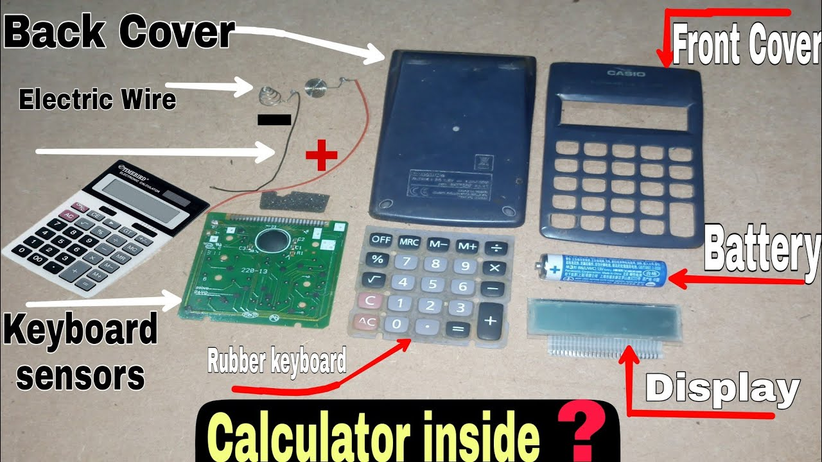

Internal Components
- Microprocessor / CPU
  - Executes arithmetic and logical operations.
  - Interprets input and controls output to display.
- Memory Chips
  - Temporary storage (RAM) for calculations.
  - Permanent storage (ROM) for built-in functions.
- Printed Circuit Board (PCB)
  - Electrical pathways connecting CPU, memory, buttons, and display.
- Electronic Components
  - Resistors, capacitors, transistors, diodes to control signals.
  - Oscillator for clock timing in calculations.
- Connector Pads / Contacts
  - Under each button to detect keypresses and send signals to CPU.
- Power Management Circuit
  - Maintains consistent voltage and prevents overload.
- Optional Ports
  - USB, data ports for advanced or graphing calculators.

4. Operation of a Calculator
A calculator’s operation can be understood as a step-by-step process from input to output:
- Input
  - Pressing a key closes a circuit, sending an electrical signal to the CPU.
- Processing
  - The CPU interprets the signal:
    - Numbers are stored in RAM.
    - Operations (+, −, ×, ÷) trigger built-in algorithms.
    - Scientific functions use more complex formulas.
  - Example: Press 7 × 8 = → CPU stores 7, multiplies with 8, calculates 56.
- Output
  - CPU sends result to the display for the user.
  - Errors like division by zero are also displayed.
- Memory / Storage (Optional)
  - Allows storing intermediate results for multi-step calculations.
- Power Supply
Ensures uninterrupted operation of CPU, memory, and display.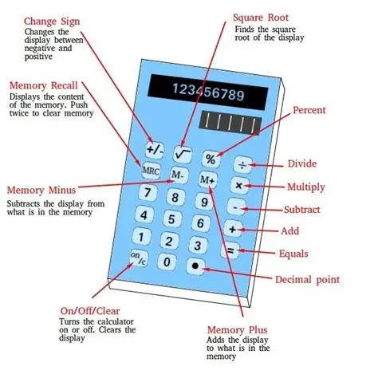
Summary:
Key Press → Signal to CPU → CPU Processes → Result Displayed → (Optional) Memory Storage

5. Purpose of a Calculator
Calculators simplify and speed up numerical calculations for a variety of users.

1. Basic Purposes
- Perform arithmetic operations: +, −, ×, ÷.
- Reduce human errors.
- Save time in daily calculations.

2. Scientific / Advanced Purposes
- Perform trigonometric, logarithmic, and exponential functions.
- Statistical operations like mean, standard deviation, regression analysis.
- Solve algebraic, geometric, and calculus problems efficiently.

3. Educational Purposes
- Learning aid to check answers and understand mathematical concepts.
- Practice tool for exams, homework, and classroom exercises.

4. Professional / Business Purposes
- Financial calculations (interest rates, profit/loss, taxes).
- Engineering and technical computations for design and problem-solving.

5. Convenience
- Portable, lightweight, and easy to operate.
- Reduces the need for manual calculation tools like pen and paper.
Summary:
A calculator makes numerical calculations faster, easier, and more accurate, suitable for students, professionals, scientists, engineers, and business users.
Different types of calculator
Performs simple arithmetic (addition, subtraction, multiplication, division).
- Scientific Calculator:Includes trigonometric, logarithmic, and exponential functions.
- Graphing Calculator:
  - Plots graphs, supports advanced mathematical modeling.
- Financial Calculator:
  - Designed for accounting, interest, and investment calculations.
- Programmable Calculator:
  - Can store custom programs or formulas for repeated use.Sure! Here’s a clear table in a box form showing types of calculators and their uses:
  - +----------------------+----------------------------------------------+
  - | Type | Uses |
  - +----------------------+----------------------------------------------+
  - | Basic Calculator | Addition, subtraction, multiplication, |
  - | | division, percentages |
  - +----------------------+----------------------------------------------+
  - | Scientific Calculator| Trigonometry (sin, cos, tan), powers, |
  - | | roots, logarithms, complex scientific |
  - | | and engineering calculations |
  - +----------------------+----------------------------------------------+
  - | Graphing Calculator | Plotting graphs, solving equations visually,|
  - | | analyzing functions and curves |
  - +----------------------+----------------------------------------------+
  - | Financial Calculator | Calculating interest, loans, mortgages, |
  - | | investments, budgeting |
  - +----------------------+----------------------------------------------+
  - | Statistical Calculator| Mean, median, standard deviation, |
  - | | probability, data analysis |
  - +----------------------+----------------------------------------------+
  - | Programmable/ | Binary, hexadecimal calculations, coding, |
  - | Engineering Calculator| engineering notation, complex formulas |
  - +----------------------+----------------------------------------------+

